USER REGISTRATION FORM FOR FOREIGN CITIZENS

User Card No (filled in by a librarian): __________________

Foreign citizens wishing to acquire or renew membership must present their passport and sign a statement that they will observe the terms for borrowing materials from the library. Library materials may not be taken outside Slovenian borders or given to another person. Members are required to notify the library of any change in personal name, home address, telephone number or email address.

SURNAME (capital letters): Kliknite tukaj, če želite vnesti besedilo.
FIRST NAME (capital letters): Kliknite tukaj, če želite vnesti besedilo.
Date of birth: _________________________
Home address: Kliknite tukaj, če želite vnesti besedilo.
City, postal code, country: Kliknite tukaj, če želite vnesti besedilo.
Temporary address in Slovenia: Kliknite tukaj, če želite vnesti besedilo.
E-mail: Kliknite tukaj, če želite vnesti besedilo.
Telephone contact (optional): Kliknite tukaj, če želite vnesti besedilo.
Membership category (please tick the relevant box and, where requested, fill in the information):
☐ Full-time foreign student, studying at UL ☐ Exchange student ☐ Visiting professor
Faculty, department: Kliknite tukaj, če želite vnesti besedilo.
Exchange programme: Kliknite tukaj, če želite vnesti besedilo.
My international exchanges officer: Kliknite tukaj, če želite vnesti besedilo.
☐ Employed Employee’s address: Kliknite tukaj, če želite vnesti besedilo.
☐ Unemployed ☐ Retired ☐ Other: Kliknite tukaj, če želite vnesti besedilo.

Statement
I, the undersigned, certify that the information provided in this registration form is accurate and complete. I will immediately report any change in personal information to the Central Humanities Library. I declare that I want to become a member of the Central Humanities Library and that I will comply with the rules and regulations of the library.

I agree that:
- in accordance with the Personal Data Protection Act, the Central Humanities Library will collect and use my personal data only to administer, support, improve, and obtain feedback on its services.
- the Court of Justice in Ljubljana shall have jurisdiction in disputes.

Date: ____________________

PLEASE FILL IN YOUR PERSONAL INFORMATION ON THE OTHER SIDE!
REGISTRATION FORM SLIP
Foreign students of the University of Ljubljana (UL) are entitled to use the information resources and services of all UL libraries. When using other UL libraries, they prove their membership in the host faculty/academic library and the expiration date of their membership with this registration form slip. Terms and conditions for use of information resources and services are not uniform throughout the system and will vary from library to library.

To choose a PASSWORD for My COBISS (My Library) and/or remotely access electronic resources, go to »COBISS+ My COBISS (My Library) Log in then click Forgotten password (only when logging in for the first time):
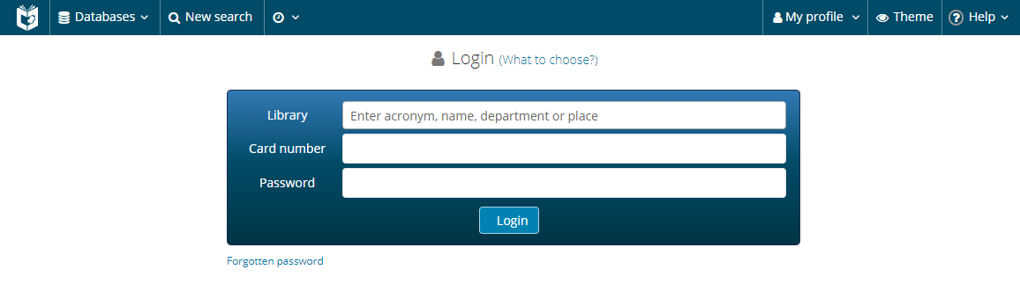

Password should be complex using letters, numbers and punctuation marks.

My COBISS My Libraries provides some useful services for library members, e. g. you can renew the loan period, make a reservation, receive a notification of an upcoming loan period expiry date, etc.

Where can you retrieve electronic materials for study and research?
- Shared Slovenian library online catalogue(s) COBISS: https://plus.si.cobiss.net (advanced search is recommended)
- Digital Library of the University of Ljubljana (DiKUL) – on COBISS (searching): https://www.cobiss.si/en/ choose Database DiKUL
- Digital Library of Slovenia (dLib): www.dlib.si

PLEASE FILL IN YOUR PERSONAL INFORMATION
SURNAME (capital letters): Kliknite tukaj, če želite vnesti besedilo.
FIRST NAME (capital letters): Kliknite tukaj, če želite vnesti besedilo.
Date of birth: __________________ City, country: Kliknite tukaj, če želite vnesti besedilo.

Foreign student’s host library during their studies or exchange programme at the University of Ljubljana:
Faculty of Arts, Central Humanities Library,
Aškerčeva 2, 1000 Ljubljana
Website: https://www.ff.uni-lj.si/ohk

Membership in this library expires on ___________________. LIBRARY STAMP

